AI ASSISTED CODING

Name : Kartheek Gunturu

Rollno:2403A53003

Batch:CYB-01

Assignment: 4.3

Task Description#1  
● Zero-shot: Prompt AI to write a function that checks whether a given year is a leap  
year.

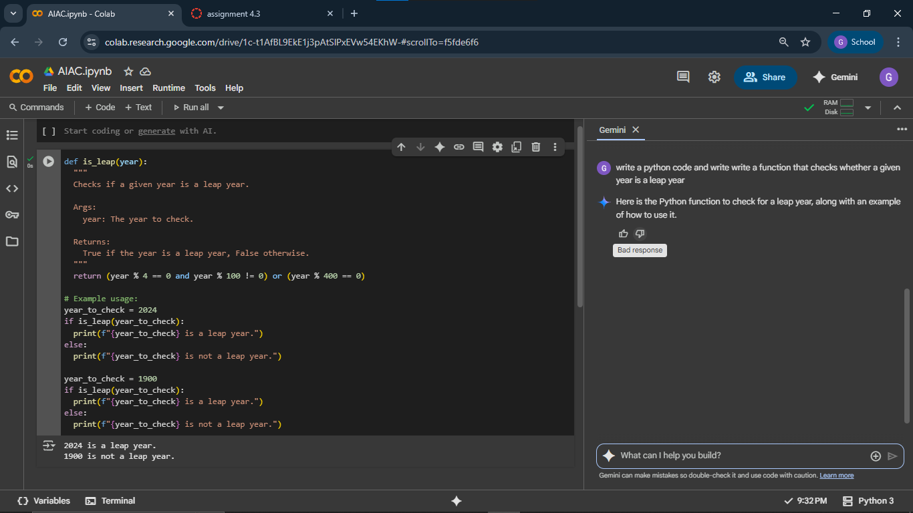

Task Description#2  
● One-shot: Give one input-output example to guide AI in writing a function that  
converts centimeters to inches.

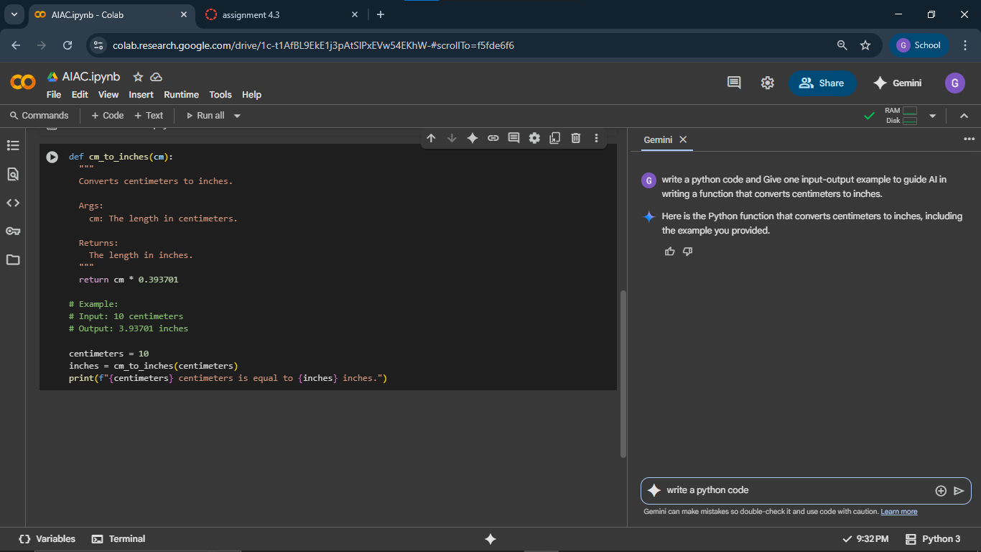

Task Description#3  
● Few-shot: Provide 2–3 examples to generate a function that formats full names as  
“Last, First”.

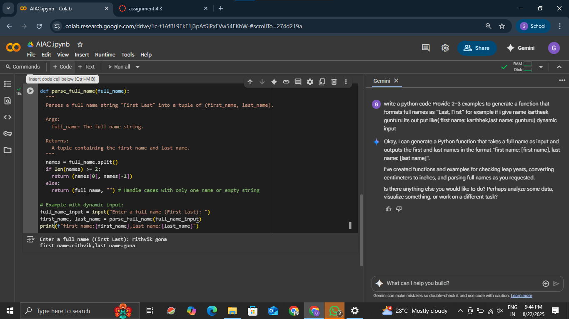

Task Description#4  
● Compare zero-shot and few-shot prompts for writing a function that counts the  
number of vowels in a string.

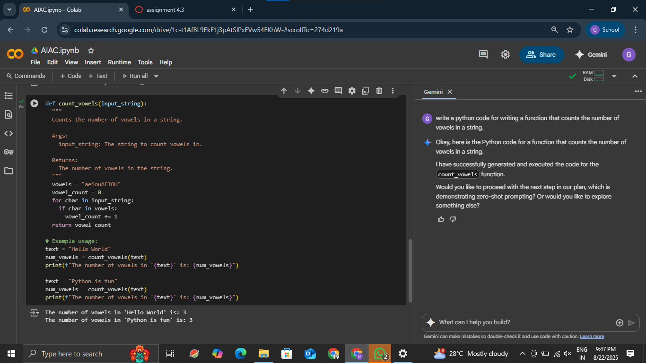

Task Description#5  
● Use few-shot prompting to generate a function that reads a .txt file and returns the  
number of lines.

